ARUNACHALA ARTS AND SCIENCE COLLEGE FOR WOMEN

(AFFILIATED BY MANONMANIAM SUNDRANAR UNIVERSITY)

VELLICHANTHAI



Submitted By

Anuja A

Fathima Nabila S

Mugisha Abi R

Prashika P

Saranya N

**ANALYSING HOUSING PRICES IN METROPOLITAN AREAS OF INDIA**

**1. INTRODUCTION**

A real estate market analysis should always be done, whether buying or selling a property, as is well help to understand the current market, how much similar properties are worth, how much you can charge for rent etc.,

1.1 OVERVIEW

India real estate market is expected to undertake a growth rate (CAGR) of 9.2% during the five years from 2023 to 2028. Looking ahead, the future of the real estate market in India appears, promising who continued growth and evolution.

The all India house price index rose by 4.52% in 2023 from 2022 according to the result released by THE NATIONAL HOUSING BANK (NHB), the country’s Central Bank.

1.2 PURPOSE

By analysing the data such as mortage payments, home equity, the age of a property, and how long the owner has lived there, agent can predict when someone might be ready to sell. Such predict analytics can give actionable insights intro tends that point to property potential and higher-quality leads.

In addition, house price predictions are also investors to know the trend of housing prices in a certain locations.

**2. PROBLEM DEFINITION & DESIGN THINKING**

2.1 Empathy Map

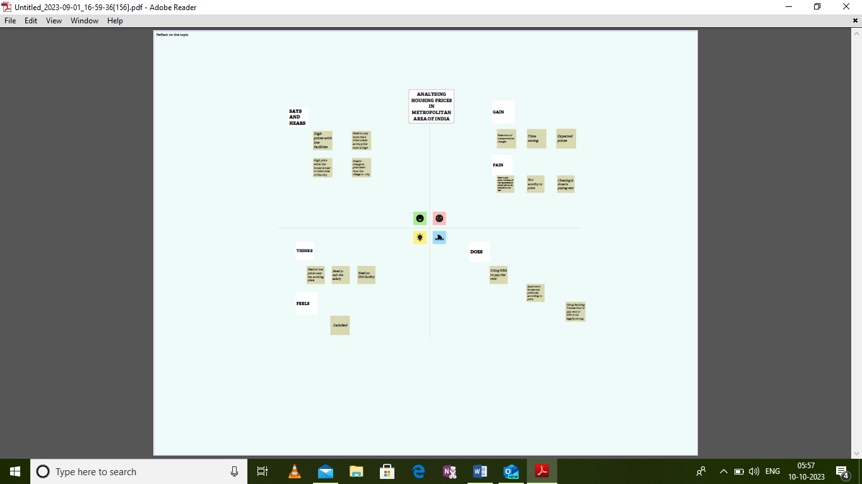

2.2. Ideation and Brainstorming Map 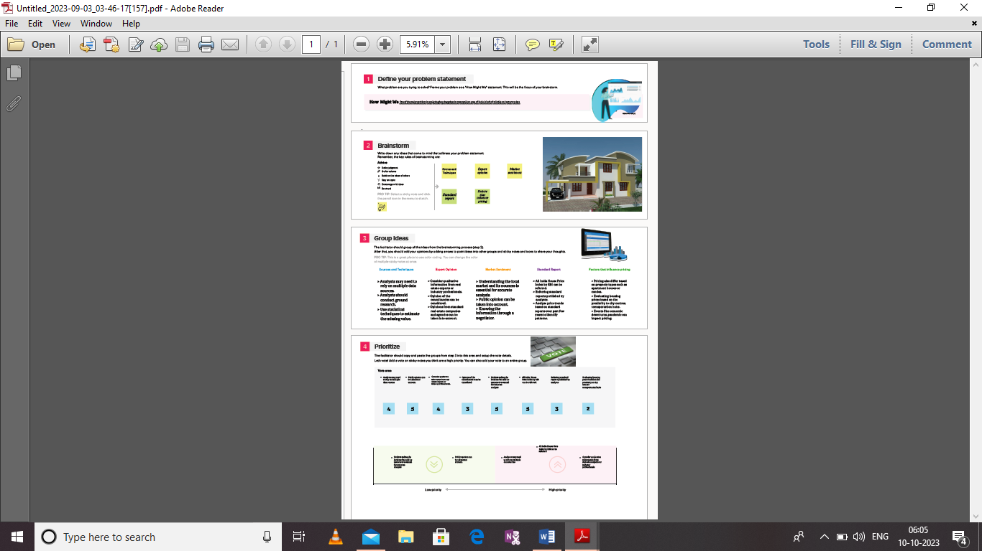

3. Results

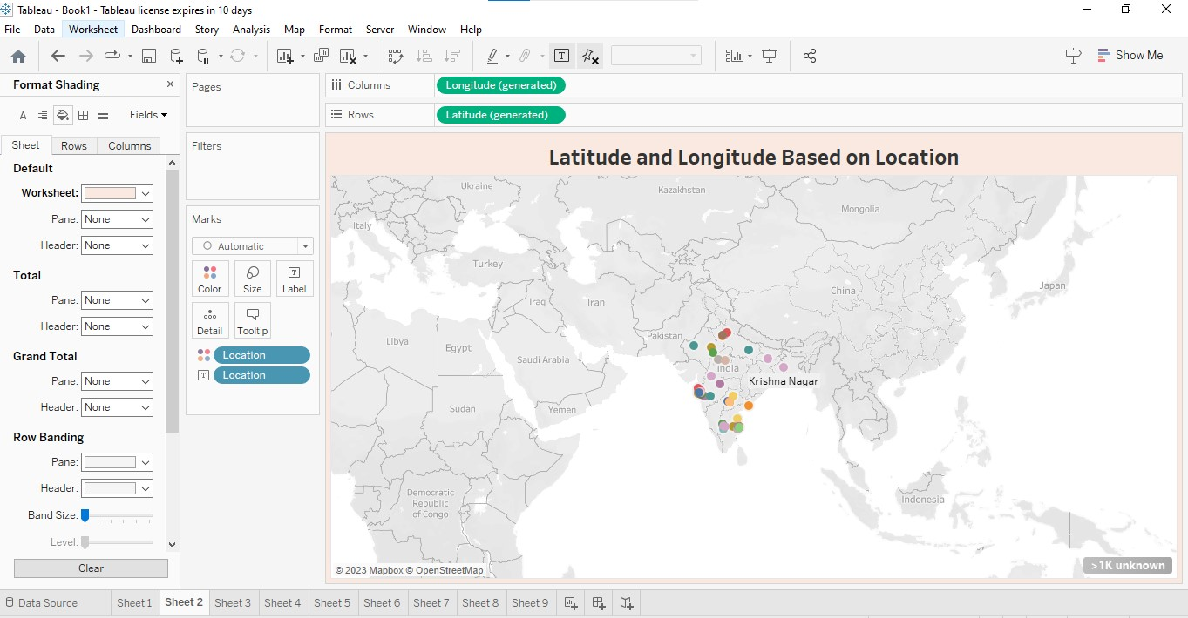

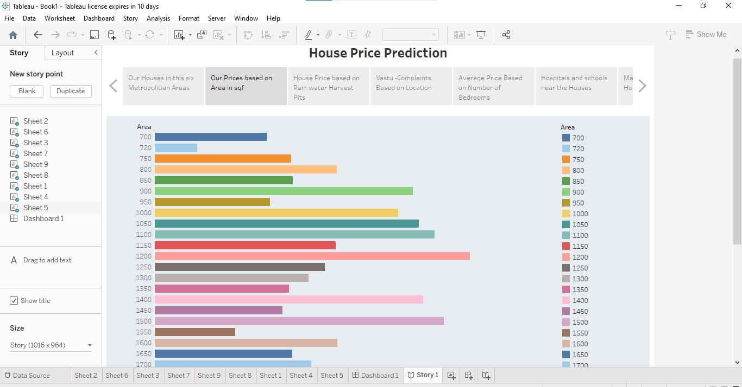

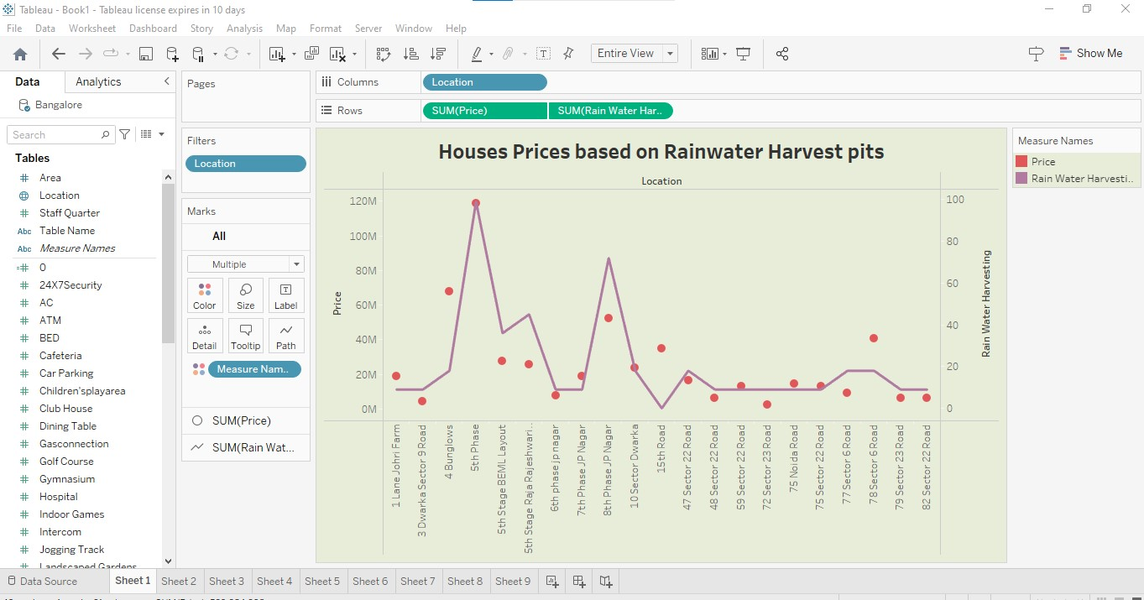

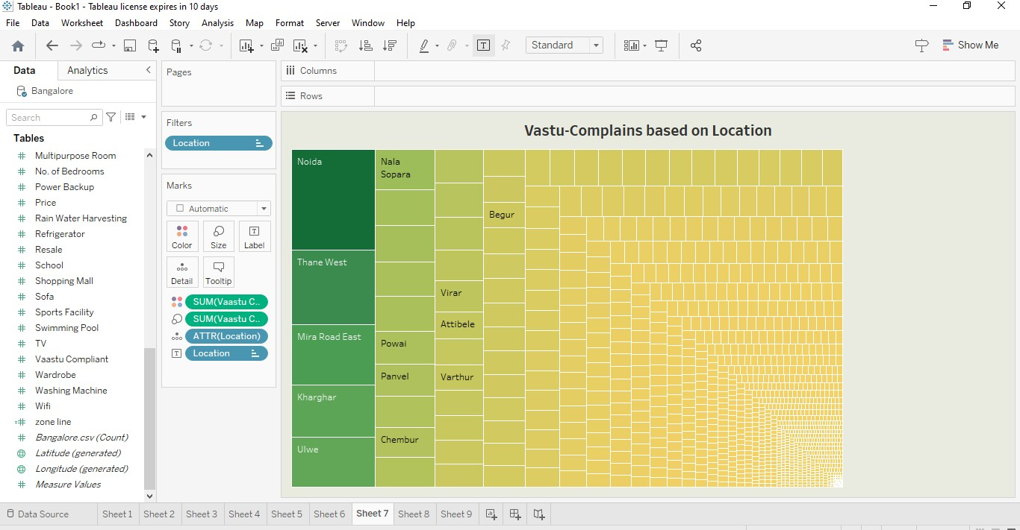

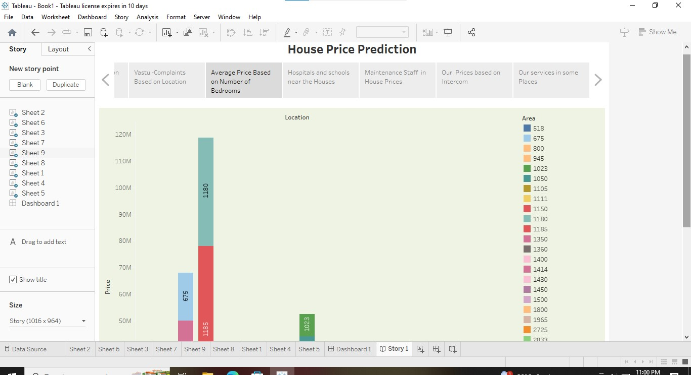

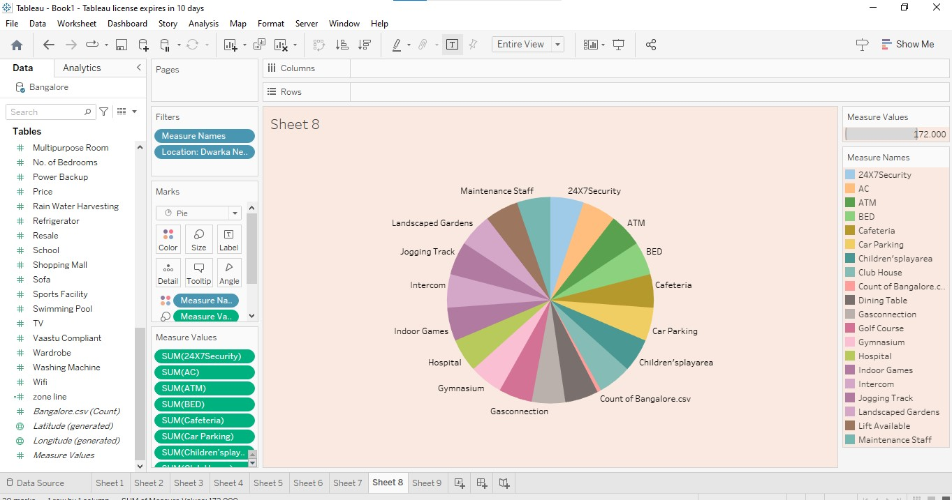

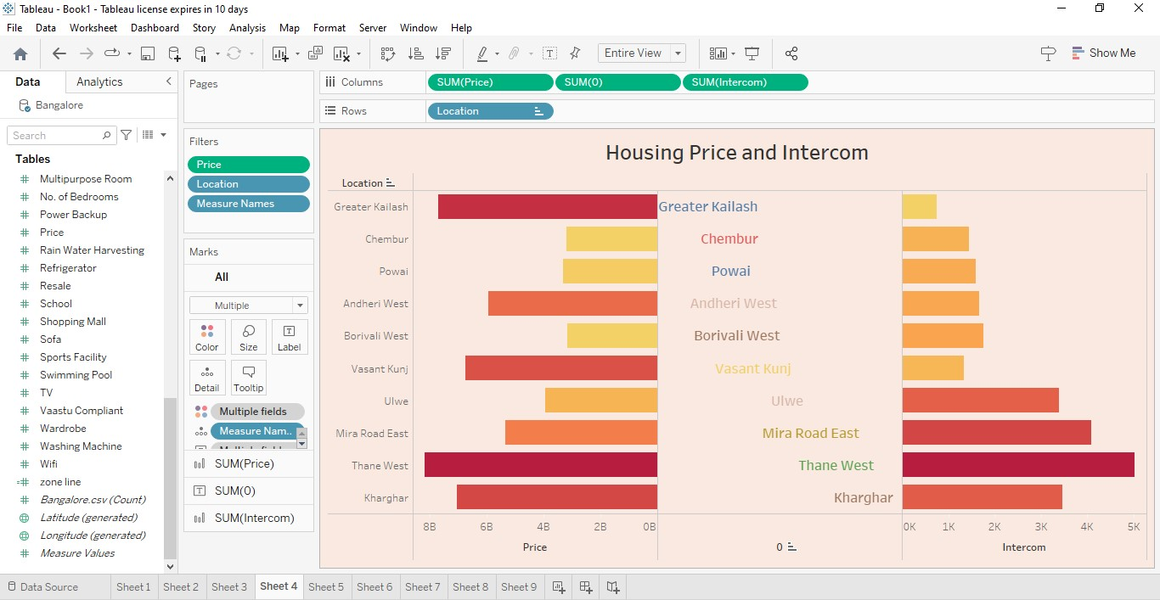

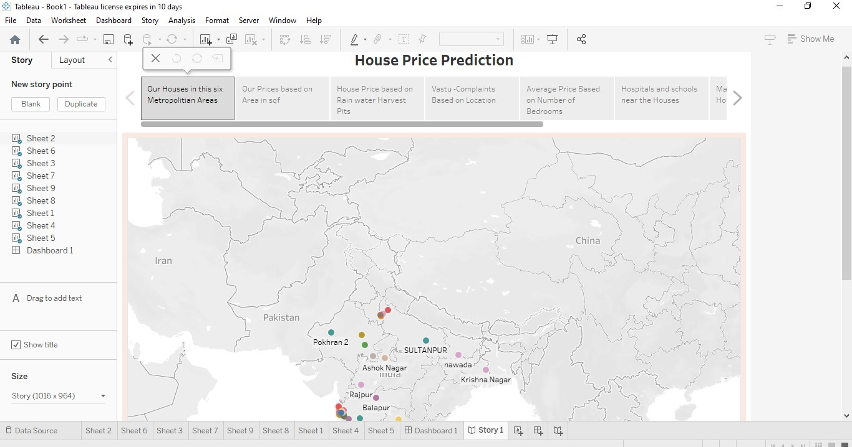

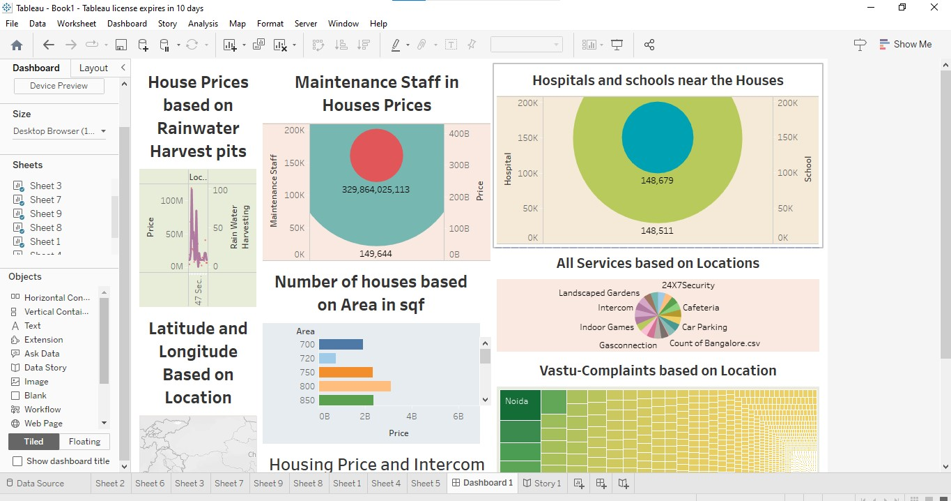

4. Advantages & Disadvantages

4.1 Advantages

* House price prediction can help the developer to determine the selling price of a house and can help the customer to arrange the right time to purchase a house.
* There are three factors that influence the price of a house which include,
* Concepts
* Locations
* Physical condition
* Make a comparison of the property with others in the same area, aspects such as size, price and other elements will help you determine the value.
* This analysis helps people to plan to buy a house so they can know the price range in the future, then can plan their finance well.
* House price predictions are also beneficial for property investors to know the trend of housing prices in a certain locations.

4.2 Disadvantages

* High cost of rent and food.
* Increased competition and social callousness. Additionally, fluctuations in interest rates, inflation rates, and the availability of home loans can also impact housing affordability and property prices.
* There are various sectors in disadvantages,
* Lack of tax shelter
* Lack of diversification
* Illiquidity
* Management problems
* Financing may not always be available. Higher interest rates may make refinancing loss feasible.
* Whether the property is maintained by owner or through a management company, constant attention must be given to the property to maintain its income and value.

5. Applications

According to the analysis, we should have a price range for the value of the property. Take into account everything you have observed and analysed how it will affect the value.

Make the comparison of the property with others in the same areas, aspects such as price, size and other elements will help you determine the value. Once we have performed the property analysis, search online for the original listing, if possible. This will give you a good idea of the overall condition of the home.

6. Conclusion

To conduct the real estate market analysis is to perform a property analysis. Thereby we can occur a knowledge about a market price and current situation of price in market. The area and neighbourhood, lot size, construction time, services and amenities, etc., should be evaluated.

7. Future scope

India’s real estate market is expected to undertake a growth rate (CAGR) of 9.2% during the five years d202d3-2028. Looking ahead, the future of the market should increase without any doubt. Average house prices were forecast to rise by 6% next year and in 2025.

8. Appendix

https://public.tableau.com/app/profile/anuja.a6769/viz/Book1_16969192267500/Dsahboard1